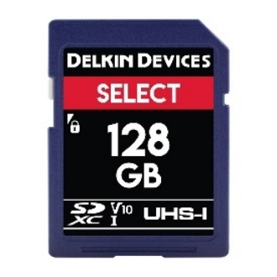
Select
More Value Every Day
4GB – 128GB
24 MB/s Read
17 MB/s Write
Class 10/U1/V10
Lifetime Warranty

Optimized for use in DSLRs, camcorders and other handheld devices, the SELECT SD card is capable of capturing smooth, continuous Full HD 1080p video.

FIND A LOCAL DEALER

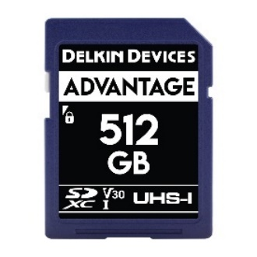
Advantage
Excellence Guaranteed
8GB – 512GB
90 MB/s Read
90 MB/s Write
Class 10/U3/V30
Lifetime Warranty

Designed to excel in DSLRs and advanced camcorders that require faster speeds, the ADVANTAGE SD card is able to record flawless 4K and Full HD footage at high-frame rates.

FIND A LOCAL DEALER

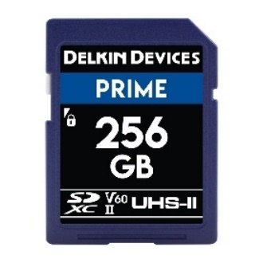
Prime
Preferred by Professionals
64GB – 256GB
300 MB/s Read
100 MB/s Write
Class 10/U3/V60
Lifetime Warranty

Ideal for professional photographers & videographers, the PRIME SD card supports various simultaneous capture modes, such as video + still + GPS data.

FIND A LOCAL DEALER

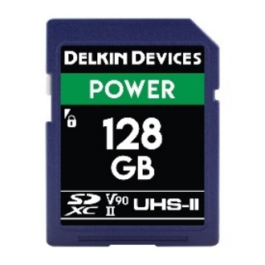
Power
Simply the Best
32GB – 128GB
300 MB/s Read
250 MB/s Write
Class 10/U3/V90
Lifetime Warranty

Utilizing the latest speed class technology, the POWER SD card boasts the fastest available speeds and supports data-intensive modes, including 8K video.

FIND A LOCAL DEALER

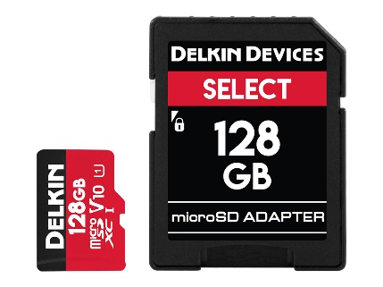

Select
More Value Every Day
16GB – 128GB
75 MB/s Read
10 MB/s Write
Class 10/U1/V10
Lifetime Warranty

Optimized for smartphones, tablets and action cameras, the SELECT microSD card is capable of capturing smooth, continuous Full HD 1080p video.

FIND A LOCAL DEALER

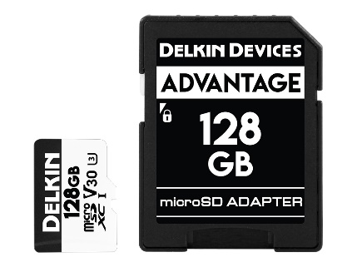

Advantage
Excellence Guaranteed
32GB – 128GB
90 MB/s Read
90 MB/s Write
Class 10/U3/V30
Lifetime Warranty

Designed to excel in the latest action cameras and drones, the ADVANTAGE microSD card is able to record flawless 4K and Full HD footage at high-frame rates.

FIND A LOCAL DEALER

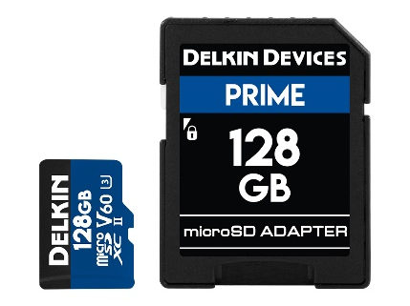

Prime
Preferred by Professionals
64GB – 128GB
300 MB/s Read
100 MB/s Write
Class 10/U3/V60
Lifetime Warranty

Utilizing the latest speed class technology, the PRIME microSD card supports data-intensive modes, including 8K & 360° video, as well as
simultaneous capture.

FIND A LOCAL DEALER

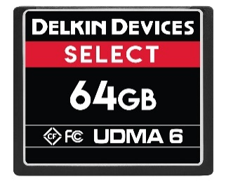

Select
More Value Every Day
4GB – 64GB
75 MB/s Read
40 MB/s Write
UDMA 6
Lifetime Warranty

Ideal for use in DSLRs, audio recorders and other handheld devices, the SELECT CF card is capable of capturing smooth, continuous Full HD 1080p video.

FIND A LOCAL DEALER

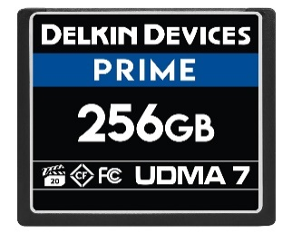

Prime
Preferred by Professionals
32GB – 256GB
160 MB/s Read
120 MB/s Write
UDMA 7
Lifetime Warranty

Designed to excel in high-end 4K cameras and digital backs, the PRIME CF card offers professional-level speeds for flawless 4K and Full HD footage at high-frame rates.

FIND A LOCAL DEALER

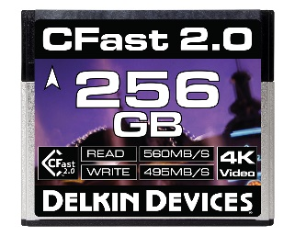

Cinema
Preferred by Professionals
128GB – 256GB
560 MB/s Read
495 MB/s Write
SATA III
Lifetime Warranty

Ideal for professional photographers & videographers, the CINEMA CFast card delivers unrivaled performance for flawless 4K cinema-quality video & rapid-fire RAW photo capture.

FIND A LOCAL DEALER

